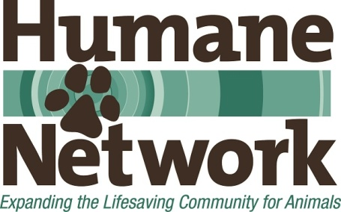
___Org Name___ Board of Directors Candidate insert your logo Application

If you are interested in becoming a member of the Board of Directors of ___Org Name___, please send a completed application and résumé via email to: ___email address____ with ___Org Name___ Board Application in the subject line. If you have questions, please email them to this same address.
Deadline for application:

Contact Information

Name: ______________________________________________

Address (including zip code):__________________________________________________________
Phone #s Cell:_____________________________________________________________________ and/or other number that is best to reach you at

Email:__________________________________________________________

Please attach a current résumé or CV.

Questions. Please feel free to use additional space.

1. Why do you want to serve on the ___Org Name___ Board of Directors?

2. Have you previously served, or are you currently serving, on other nonprofit boards? Please elaborate.

3. What is your current or recent past connection to ___Org Name___? (past or current volunteer, adopter, former staff, donor, etc. If past or former, please share why the relationship ended.)

4. Please describe your management and/or leadership experience, and any specific skills, experience, or background that you would bring to ___Org Name___.

5. Please elaborate on any other areas of expertise you possess that you would be willing to use to help ___Org Name___ (Examples: animal welfare/sheltering/rescue experience, legal, human resources, fundraising, financial/accounting, marketing, event planning, etc.)

6. Are you able to meet the board requirements listed in the accompanying document?

7. Do you have any questions for us? Please elaborate.

8. Is there anything else you would like to share?

References: Please list three references we can call who can speak to your professional or volunteer experience and performance. Please provide name, email address and phone number, and be sure to note how you know this individual. Please avoid using relatives as references.

Thank you so much for your interest in the ___Org Name___ Board and for taking the time to reach out to us.

