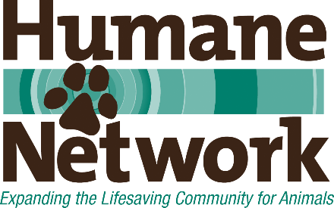
Sample CEO Orientation/On Boarding Process

- Meet with Key Staff Individually (including these and any other manager or director level roles)
  - Operations Director/COO / Shelter Manager
  - Administrative Services Manager and/or HR, Bookkeeping, etc.
  - Communications, Marketing and Events Manager(s)
  - Development Manager
  - Animal Care Managers
  - Adoptions Manager
  - Programs or Outreach Managers (including Volunteer, Foster Program, etc)
  - Pet Resource/Help Desk/Managed Admissions/Intake Manager
  - Field Services Manager
  - Each veterinarian, individually
  - Clinic Manager
  - Maintenance and Janitorial Manager

- Documents to Review (order does not indicate importance):
- Organization chart
- Policies, procedures, SOPs
- Annual Impact Reports
- Current Financials
- Audited Financials
- Form 990
- Board member agreements and on boarding package for board members
- Employee manual, on boarding information/training
- Organization’s bylaws
- Contracts and Agreements
- Recent Strategic Plans
- Current Mission and Goals
- Animal Statistics
- Recent/Last assessment report
- List/description of current programs
- Most recent year’s fundraising and promotional materials

- Meet with Stakeholders (Staff/BOD/Volunteers/Donors)
  - All staff as whole group in each location(maybe couple sessions to accommodate different schedules)
  - Citizen advisory group (if exists)
  - Volunteers as a whole group
  - Key donors, individuals and perhaps a focus group or reception for donors
  - Lunch meeting with Board Chair and/or President

- Meet with other Animal Welfare Leadership
  - Animal Services OR Humane Society/SPCA Director
  - Leadership of any active or potentially active rescue groups
  - Other directors of similar agencies in the state
  - Plan calls with all major foundation/grant funders
  - Community Foundation

- Meet with Public Officials
  - County commissioners or city council members(each of them individually)
  - Mayors of major cities
  - Lobbyist, if have one
  - State legislators

- Meet with Key Partners/Contacts
  - Media (print, TV, etc.)
  - Businesses that are substantial partners
  - Key vendors (over time) IT, Health insurance, Liability insurance, Manager of any investment accounts

